26(A) . in pl/SQL viewing out parameter in application express.

Create table:

CREATE TABLE employees (

employee_id NUMBER PRIMARY KEY,

last_name VARCHAR2(50),

salary NUMBER(10, 2)

);

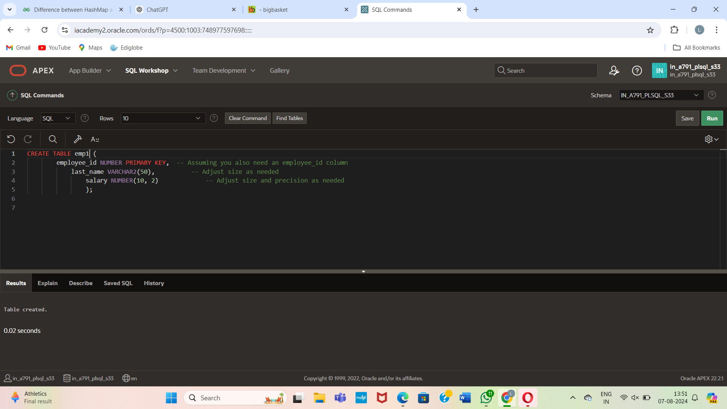

Insert values:

INSERT INTO employees (employee_id, last_name, salary) VALUES (178, 'Smith', 55000.00);

INSERT INTO employees (employee_id, last_name, salary) VALUES (179, 'Johnson', 62000.00);

INSERT INTO employees (employee_id, last_name, salary) VALUES (180, 'Williams', 54000.00);

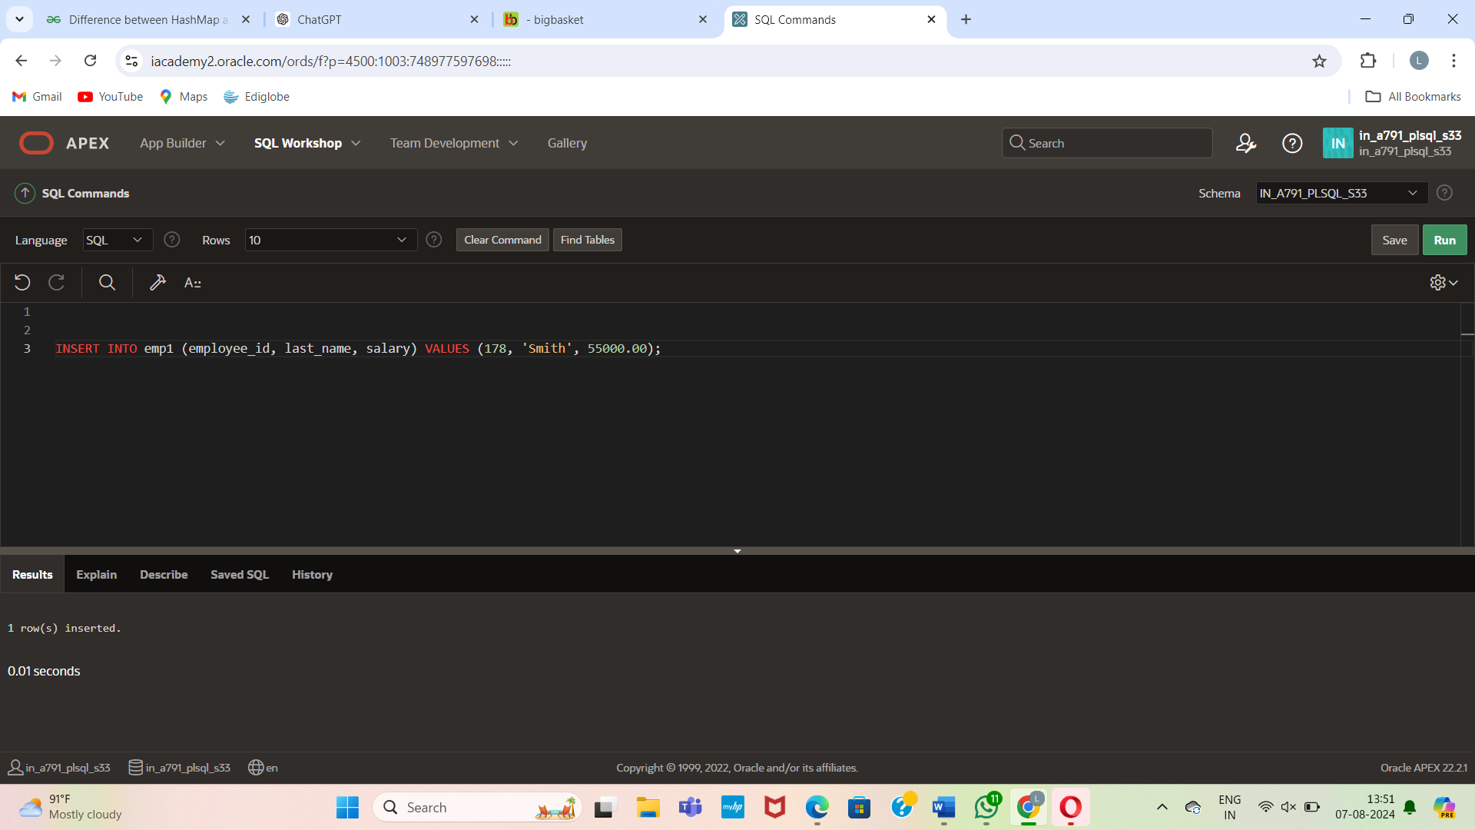

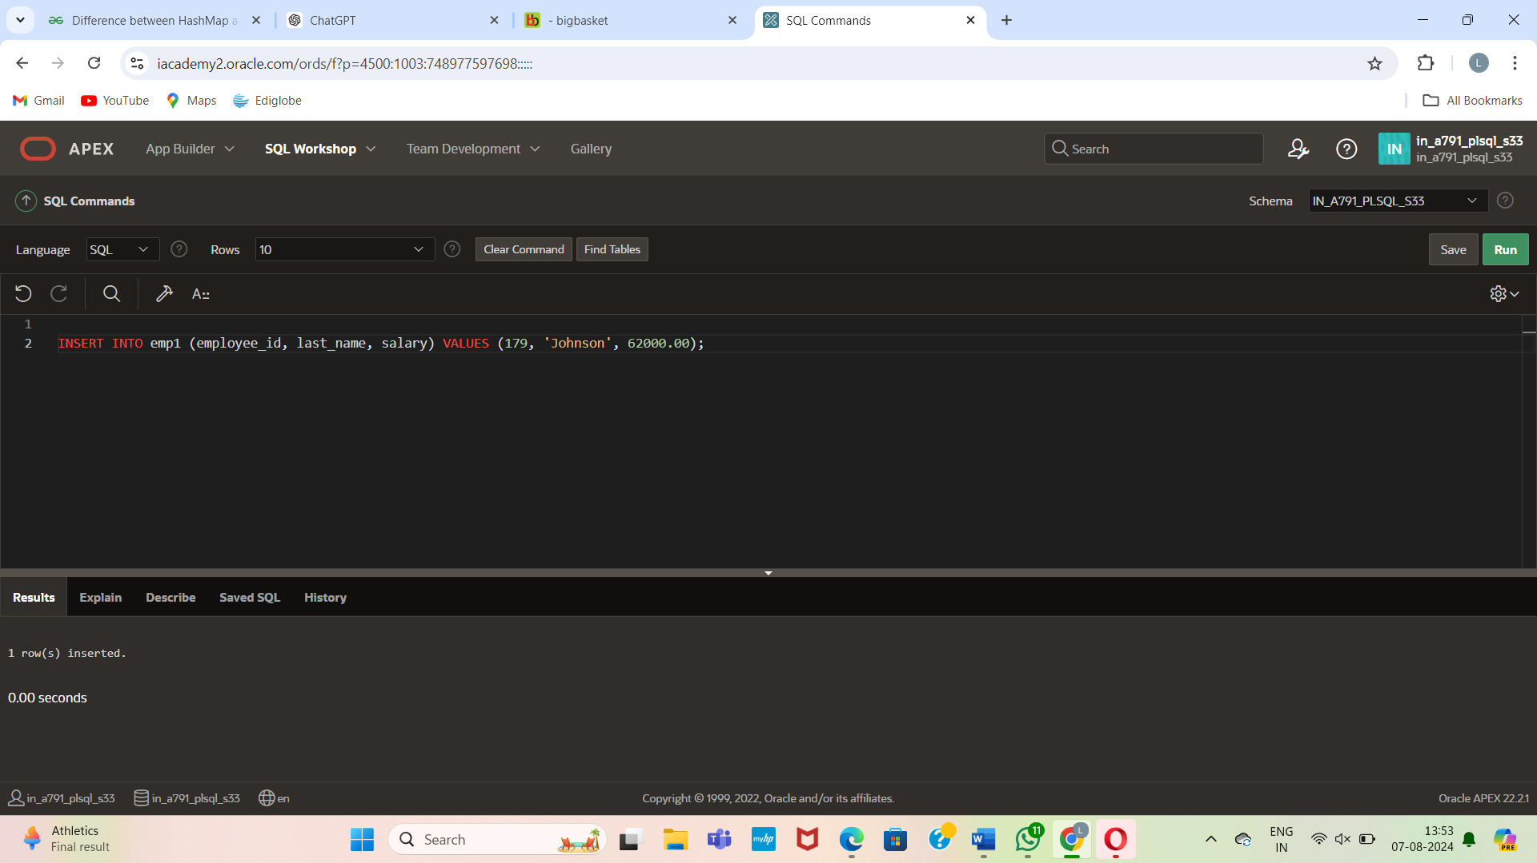

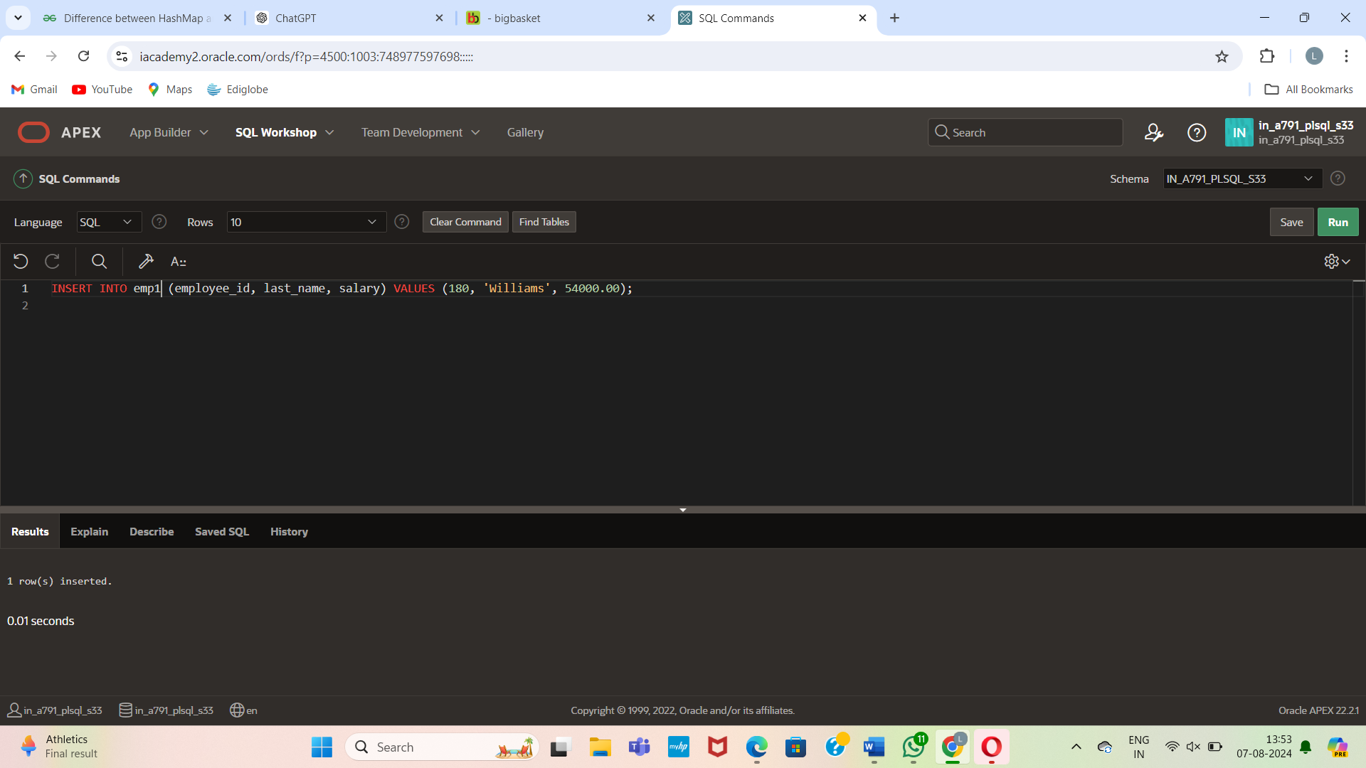

Create the **query_emp** procedure:

CREATE OR REPLACE PROCEDURE query_emp (

p_emp_id IN employees.employee_id%TYPE,

p_emp_name OUT employees.last_name%TYPE,

p_emp_sal OUT employees.salary%TYPE

) AS

BEGIN

SELECT last_name, salary

INTO p_emp_name, p_emp_sal

FROM employees

WHERE employee_id = p_emp_id;

EXCEPTION

WHEN NO_DATA_FOUND THEN

p_emp_name := NULL;

p_emp_sal := NULL;

END;

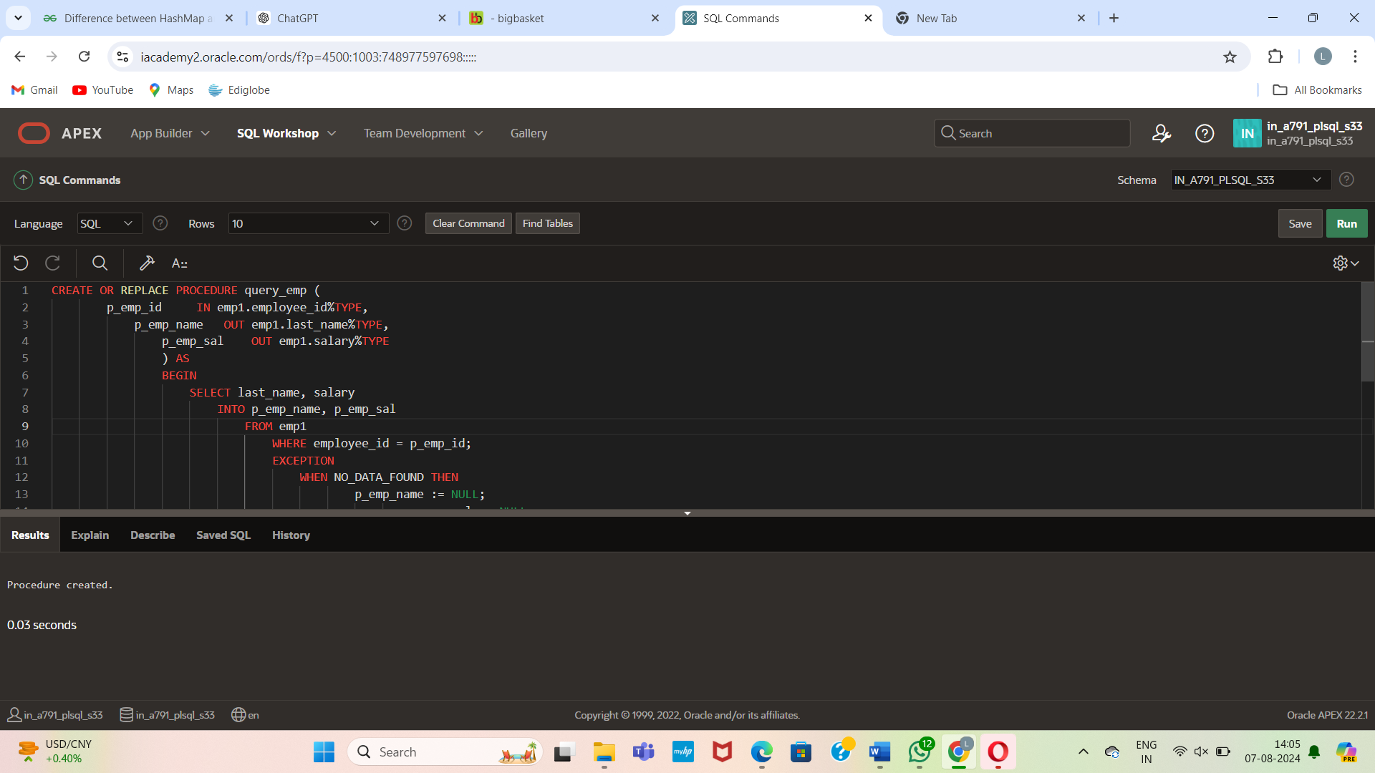

Now, execute the PL/SQL block:

DECLARE

a_emp_name employees.last_name%TYPE;

a_emp_sal employees.salary%TYPE;

BEGIN

query_emp(178, a_emp_name, a_emp_sal);

DBMS_OUTPUT.PUT_LINE('Name: ' || a_emp_name);

DBMS_OUTPUT.PUT_LINE('Salary: ' || a_emp_sal);

END;

